신채운/202135789

## STEP 1: understand the problem (requirements analysis)

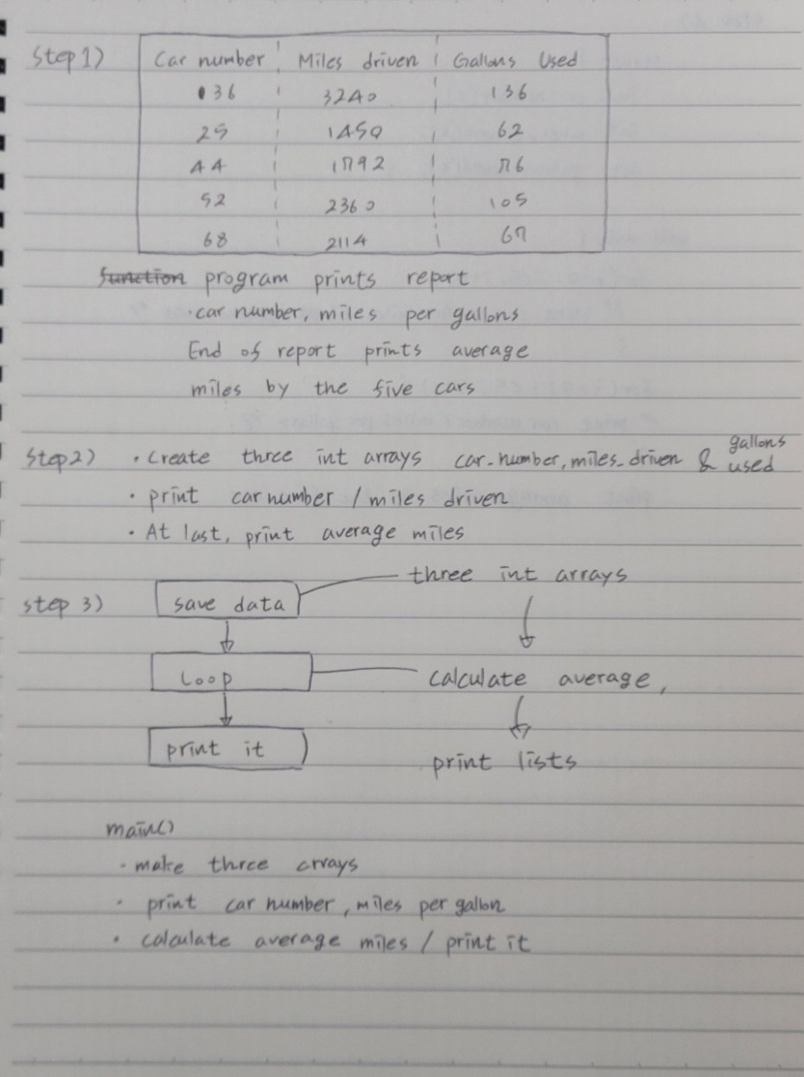

## STEP 2: outline a solution (basic design)

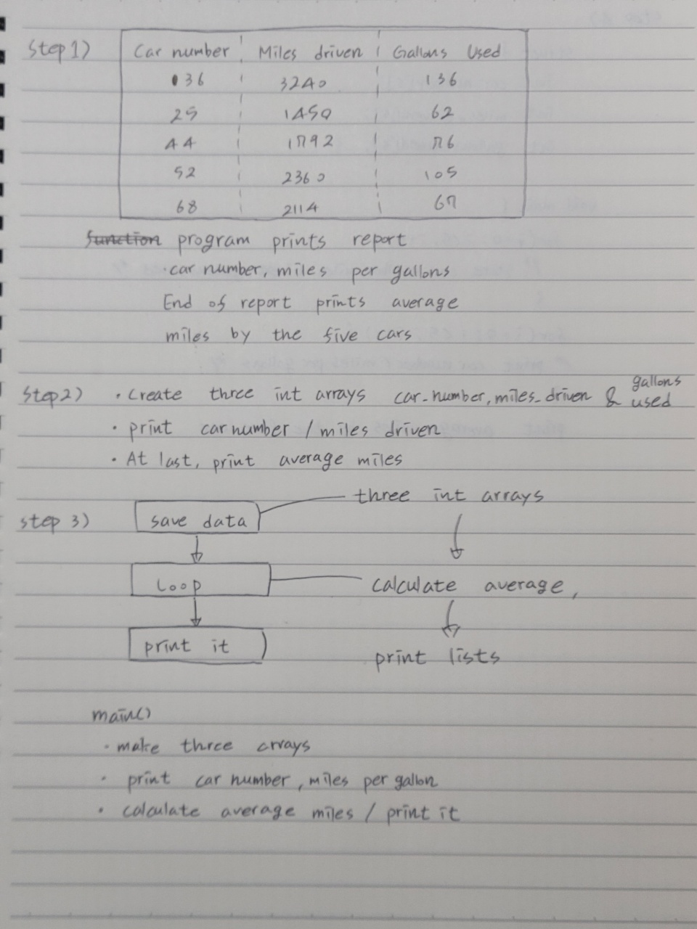

## STEP 3: form a program structure (basic design)



## STEP 4: write a program outline (pseudo code)

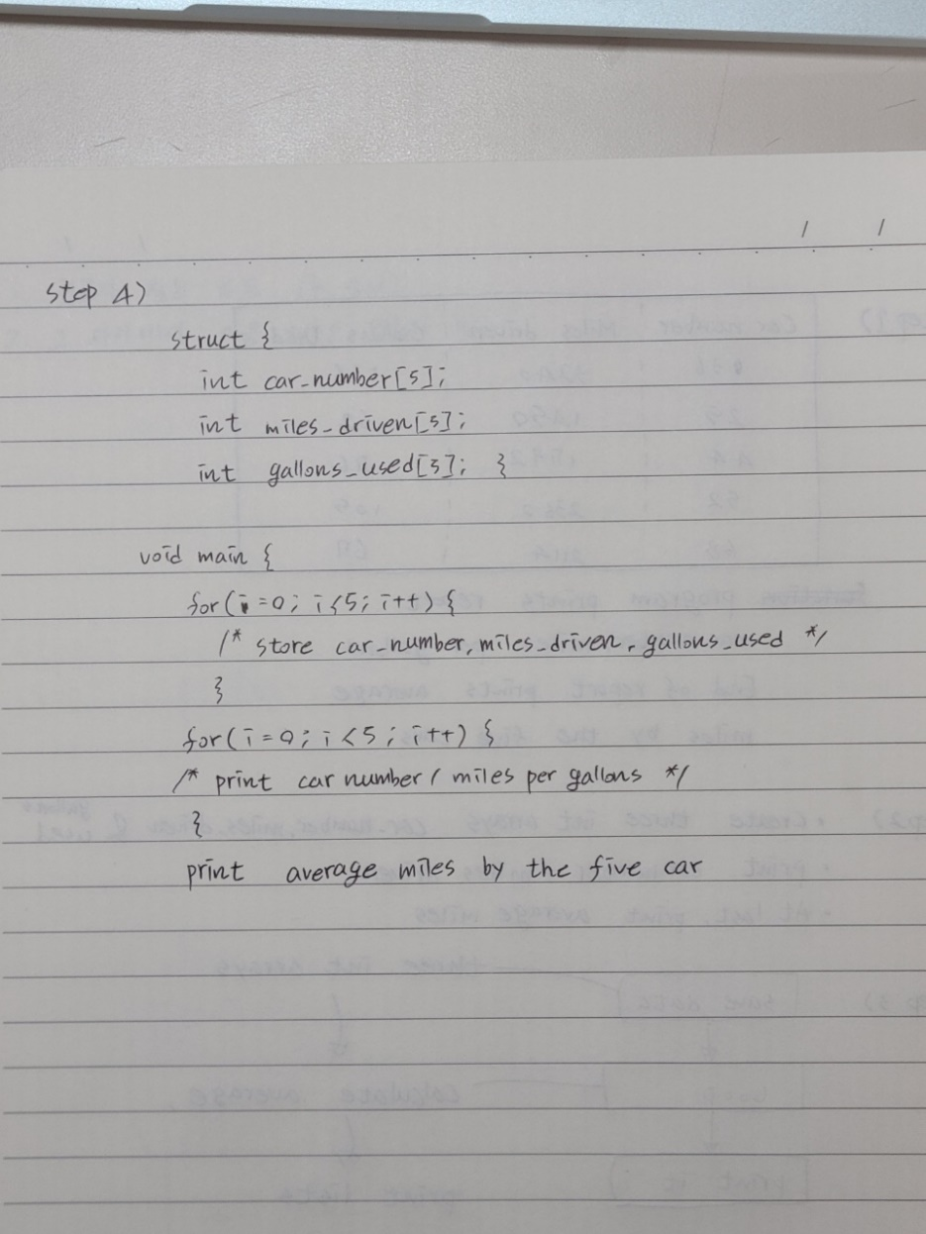

## Source codes & Comment

// 아래 네모 안에 코드를 복사하여 붙일 것

|  |
| --- |
| #include <stdio.h>  /*  file name:Exercise 12.2 4a  author:202135789 신채운  date:9/30  Course:Problem Solving Methods  description:  Store Car number,Miles driven,gallons Used in structure.  program create a report(car number,miles per gallons achieved by the car)  End of report,include the average miles per gallons by the five car  */  struct {  int car_number[5];  int miles_driven[5];  int gallons_used[5];  } CARS;  void main() {  for (int i = 0; i < 5; i++) { //loop for store datas  printf("\nPlease type car's number: ");  scanf_s("%d", &CARS.car_number[i]);  printf("\nCar number %d`s miles driven: ", CARS.car_number[i]);  scanf_s("%d", &CARS.miles_driven[i]);  printf("\nCar number %d`s gallons used: ", CARS.car_number[i]);  scanf_s("%d", &CARS.gallons_used[i]);  }  int average = 0;  for (int i = 0; i < 5; i++) { //loop for calculate average  printf("\nCar number: %d / Miles per gallon: %d", CARS.car_number[i], CARS.miles_driven[i] / CARS.gallons_used[i]);  average = average + CARS.miles_driven[i] / CARS.gallons_used[i];  }  printf("\nAverage miles per gallon achived by the five cars: %d", average / 5);  } |

## Inspect the program (testing)

// 자가 점검 후 네모 안에 v표시

🗹 Check loop, if else, switch, function.

🗹 Check variable initialization.

🗹 Check pointers.

## Test cases & Output (Screenshots)

|  |  |
| --- | --- |
| # | Screenshot |
|  | |